4-Day Primate Safari Uganda -Rwanda

This journey allows you to discover the true beauty of Rwanda and Uganda. You can choose to begin and conclude this trip in either Uganda or Rwanda. There will be opportunities for Rwanda city tour, chimpanzee trekking in Kibale National Park and gorilla trekking in Bwindi Impenetrable National Park
ROUTE
Rwanda
Start | Kigali (Day 1)
Uganda
Day 1 | Bwindi Impenetrable NP (Gorillas)
Day 2 | Lake Bunyonyi
Day 3 | Kibale NP (Chimps)
End | Entebbe (Entebbe) (Day 4)

Tour Features

Mid-range tour
This mid-range tour uses lodges and resorts.

Private tour
This tour will be organized exclusively for you and won't be shared with others.

Can start any day
If availability permits, this tour can start on any day.

Can be customized
You can request minor changes to the accommodations and destinations of this tour.

Suitable for solo travelers
Solo travelers can book this private tour.
15

Minimum age of 15 years
The minimum age for this tour is 15 years.

Activities & Transportation

Activities: gorilla trekking & chimpanzee trekking

Getting around: pop-up roof 4x4 vehicle & normal 4x4 vehicle

A transfer from and back to the airport is included

Accommodation & Meals
- Additional accommodation before and at the end of the tour can be arranged for an extra cost
- Day
Accommodation
Meals
- 1
Gorilla Leisure LodgeMid-range lodge bordering Bwindi Impenetrable NP (Gorillas) without fences

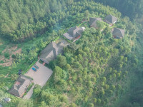

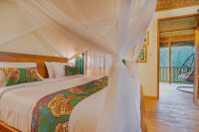

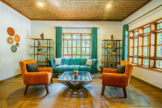

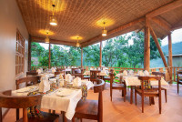+12Photos

Lunch & Dinner Included
- 2
BirdNest ResortMid-range resort at Lake Bunyonyi

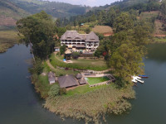

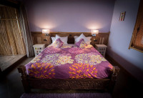

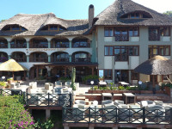

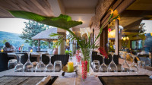+4Photos

All Meals Included
- 3
Turaco Treetops LodgeMid-range lodge bordering Kibale NP (Chimps) without fences

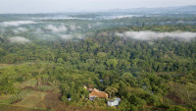

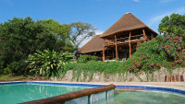

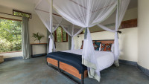

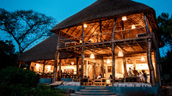+18Photos

All Meals Included
- 4
End of tour
(No accommodation)
All Meals Included

Day by Day

Arrival (See Getting There for more details)
- You'll be collected from the airport.
- Accommodation before the tour starts can be arranged for an extra cost.
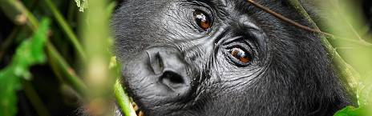

Day 1

Arrival and Pick up Transfer to Bwindi Impenetrable National Park
On arrival at Kigali International Airport, our guide from Kajie Aafries will meet and greet you. After that, you will head out on a city tour in Kigali. You'll visit the Genocide Memorial Center and the local markets and have lunch in Kigali. Then, you'll transfer to Bwindi Impenetrable National Park at your lodge for relaxation.
Main Destination:
Bwindi Impenetrable National Park (Gorillas)
Best Time To VisitJune to August and December to February (Gorilla trekking is easiest)
High SeasonJune to September (Gorilla permits are scarce)
Best WeatherJune to July and December to February (Less rainfall)

Wildlife in Bwindi Impenetrable NP
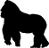
GorillaCommon

ChimpanzeeRare

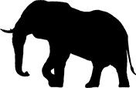
ElephantRare


White RhinoNone


Black RhinoNone


LionNone

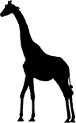
GiraffeNone


LeopardNone


CheetahNone


BuffaloNone

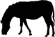
ZebraNone

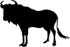
WildebeestNone


HippoNone
Accommodation:
Gorilla Leisure Lodge
- Mid-range lodge bordering Bwindi Impenetrable NP (Gorillas) without fences







+12Photos

Meals & Drinks:
- Lunch & dinner (Breakfast not included)
- Drinking water (Other drinks not included)
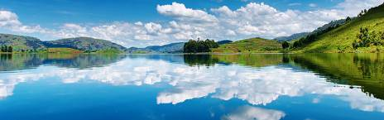

Day 2

Gorilla Trekking and Transfer to Lake Bunyonyi
You will wake up for an early morning breakfast at your lodge. After your breakfast, you will be driven to the park headquarters to start your gorilla trekking experience.
At the park headquarters, you will be briefed about the gorilla trekking activity before continuing in the forest to look out for the gorillas in the impenetrable forest.
During the gorilla trekking experience in Bwindi forest, you will follow different trails in the impenetrable forest as you search for the gorillas in their natural habitat.
You will spend 1 hour with the gorillas, and after the gorilla trekking experience, you will trek back to the briefing point at the park headquarters, where you will be met by your guide, who will drive you back to your lodge for lunch. Afterward, you'll transfer to Lake Bunyonyi, the second deepest lake in Africa, where you will relax the whole evening viewing the islands from your lodge.
Main Destination:
Lake Bunyonyi (Uganda)
Accommodation:
BirdNest Resort
- Mid-range resort located at Lake Bunyonyi







+4Photos

Meals & Drinks:
- All meals included
- Drinking water (Other drinks not included)
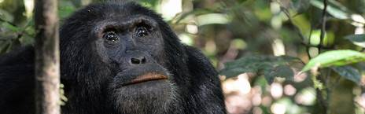

Day 3

Transfer to Kibale National Park
After your breakfast, you'll transfer to Kibale National Park, check out, and embark on your journey. This will be a whole-day journey drive where you have lunch en route. Kibale is popular for its primates, such as chimpanzees, Colobus monkeys, mangabeys, and red-tailed monkeys. On your chimpanzee trails, these are regularly seen swinging in the forest trees and others feeding on the wild fruits. You will reach your accommodation and do little but check in. Later, you'll head out for the Bigodi nature walk. Afterward, you'll go back to your lodge. You'll enjoy dinner and your overnight rest.
Main Destination:
Kibale National Park (Chimps)
Best Time To VisitJanuary to February and June to July (Chimp trekking is easiest)
High SeasonJune to September (Peak time for Uganda)
Best WeatherJanuary to February and June to July (Least rain)

Wildlife in Kibale NP
ChimpanzeeCommon


ElephantOccasional


BuffaloOccasional


LionVery Rare


LeopardVery Rare


HippoRare


GiraffeNone


White RhinoNone


Black RhinoNone


CheetahNone


ZebraNone


WildebeestNone
Accommodation:
Turaco Treetops Lodge
- Mid-range lodge bordering Kibale NP (Chimps) without fences







+18Photos

Meals & Drinks:
- All meals included
- Drinking water (Other drinks not included)
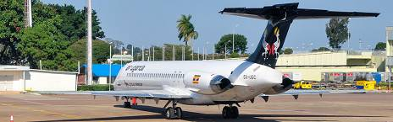

Day 4

Chimpanzee Trekking and Transfer to Entebbe
You will head to the forest head office for a briefing. Thereafter, you'll start your trek with a ranger as early as 8:00 am. Kibale National Park boasts the highest number of primate species in the world, including chimpanzees. Approximately 5,000 chimpanzees live in the wild in Uganda, which makes it a perfect place to spot them!
Once you locate the chimpanzees, you will have a full hour with them. You will return to the lodge for lunch after which you will set off your journey to Entebbe /Kigali.
Main Destination:
Entebbe International Airport (Entebbe, Uganda)
Accommodation:
No accommodation (End of tour)
Meals & Drinks:
- All meals included
- Drinking water (Other drinks not included)

End of tour (See Getting There for more details)
- Additional accommodation can be arranged for an extra cost.
- You'll be dropped off at the airport.

Rates

Important to Know
- Rates are per person and exclude the international flight from/to your home country.
- This tour accepts children who are 15 years and older.

Rates Per Person
Start dates | Solo1 room | 2 people1 room | 3 people2 rooms | 4 people2 rooms | 5 people3 rooms | 6 people3 rooms
Jan 1, 2025 - Dec 31, 2025 | $3,402 | $2,518 | $2,224 | $2,072 | $1,997 | $1,939
Jan 1, 2026 - Dec 31, 2026 | $3,402 | $2,518 | $2,224 | $2,072 | $1,997 | $1,939
Jan 1, 2027 - Dec 31, 2027 | $3,402 | $2,518 | $2,224 | $2,072 | $1,997 | $1,939

Inclusions

Included
- Park fees(For non-residents)
- Gorilla permits(One per person, non-resident)
- Chimp permits(One per person, non-resident)
- All activities(Unless labeled as optional)
- All accommodation(Unless listed as upgrade)
- A professional driver/guide
- All transportation(Unless labeled as optional)
- All Taxes/VAT
- Roundtrip airport transfer
- Meals(As specified in the day-by-day section)
- Drinking water(On all days)

Excluded
- International flights(From/to home)
- Additional accommodation before and at the end of the tour
- Tips(Tipping guideline US$10.00 pp per day)
- Personal items(Souvenirs, travel insurance, visa fees, etc.)
- Government imposed increase of taxes and/or park fees

Interested in This Tour?

